Child First Speech, LLC. 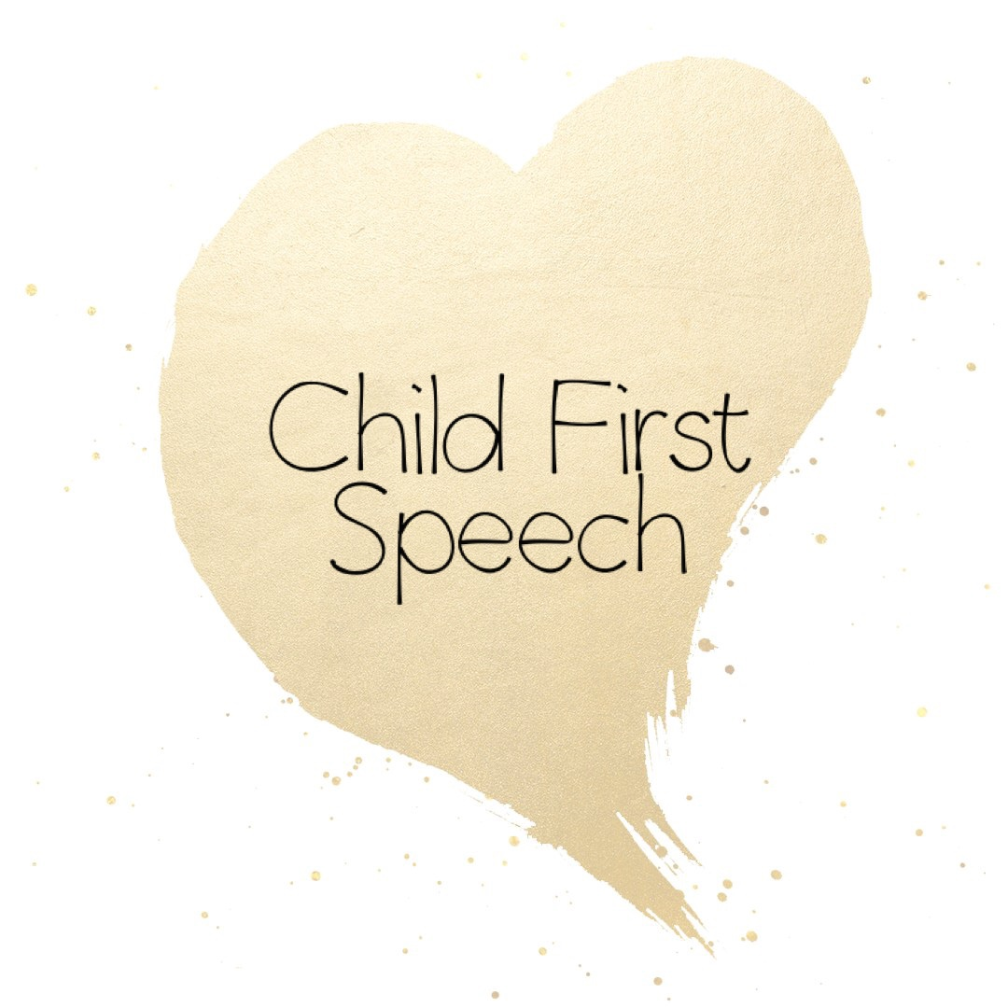
Intake Form

Child’s Name: DOB:

CHILD HISTORY –(Please complete the form to the best of your ability. If the question does not apply, leave blank)

What are your concerns regarding your child’s speech and/or language?

When did you first notice the issue(s)?

Do you feel that your child’s speech and/or language is different than children his or her own age? If so, how?

Has your child ever received a speech language evaluation?

When? How has this issue changed since you first noticed it?

Siblings: Names & Ages

Are there any family members or relatives who have or had any speech, language, or hearing issues or therapy?

Pregnancy, Birth History and Early Development

During pregnancy/birth with this child, were there any medical problems?

Type of Delivery: Vaginal or Caesarian

Was feeding a problem after birth? If so explain

Bottle fed? Breast fed? Age weaned from breast? Weaned from bottle?

Age drank independently from an open cup: finger fed self:

Is your child able to eat with a spoon and fork? Does your child have any problems eating now?

Does your child eat: Pureed foods? Yogurt/Pudding? Crunchy foods? Cookies/Pretzels?

When did your child first learn to: Crawl? Sit alone? Feed self? Dress self? Walk independently?

How well does your child: Walk? Run? Throw a ball?

If your child has difficulties with any of the above or any other motor activities, please explain:

Is your child potty trained?

Has your child ever been hospitalized? Age and reason:

Has your child ever had any serious illnesses or accidents? Explain

Does your child have problems hearing? Ear Infections? If so, how many? Last hearing exam date and results:

Does your child have any vision problems?

Does your child have any trouble sleeping at night? Waking up in the morning? Explain:

Does your child have allergies or asthma?

List any medications your child is on:

Is your child presently being treated by a pediatrician? ENT? Psychologist? Therapist? Neurologist? Physical Therapist? Occupational Therapist?

Any other pertinent medical history?

Speech History

Was your child very quiet as a baby? Did he/she coo? Babble? Did your child cry excessively as a baby?

When did your child speak single words (other than “mama” or “dada”):

What were your child’s first few words?

Approximately how many words did your child have at around 18 months?

When did your child begin to combine words (two words)?

Does your child get frustrated by his/her difficulty or inability to communicate?

Does your child speak in complete sentences?

Please state any additional information or comments you feel would helpful to me in evaluating your child’s speech/language behavior:

I look forward to meeting you and your child!
Thank you,
Heidi Patterson, M.A., CCC-SLP

